**MID EXAM UGD PROGRAM DEEP LEARNING(SPRING-2025)**

**Question 1:**

a. What do you understand by the term feed forward network and backward propagation.

b. What is activation function and why we use activation functions? Name any three Activation function.

**Question 2:**

In figure given below you have to label each and every part of the given MLP which we discussed in class and find out the Total Number of Trainable parameters.

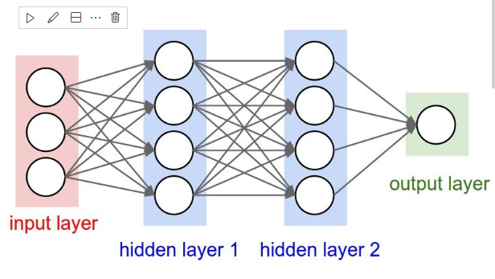

**Question 3:**

1. **Dataset Loading:**
   * Load the CIFAR-100 dataset using a standard library such as tf.keras.datasets.
2. **Data Exploration and Visualization:**
   * Display a sample of the images along with their class labels.
   * Review and understand the 100 available classes.
3. **Data Preprocessing:**
   * Normalize the image pixel values to the [0, 1] range.
   * One-hot encode the categorical class labels.
4. **Model Construction:**
   * Build a deeper Convolutional Neural Network (CNN) architecture appropriate for classifying 100 categories.
   * Ensure the model includes regularization (e.g., dropout, batch normalization) as needed.
5. **Model Training:**
   * Train the CNN on the CIFAR-100 training set.
   * Monitor training and validation performance using learning curves (e.g., accuracy and loss vs. epochs).
6. **Model Evaluation:**
   * Evaluate your model on the test set and report overall accuracy.
   * Generate and display a confusion matrix.
   * Report class-wise accuracy if possible to understand model performance per category.
7. **Discussion:**
   * Discuss the key challenges faced when working with CIFAR-100 (e.g., fine-grained distinctions between classes, limited resolution).